Laser Projector
By Fazakas Szabolcs

October 7, 2006

Advisor: Mircea Dabacan
Technical University of Cluj-Napoca

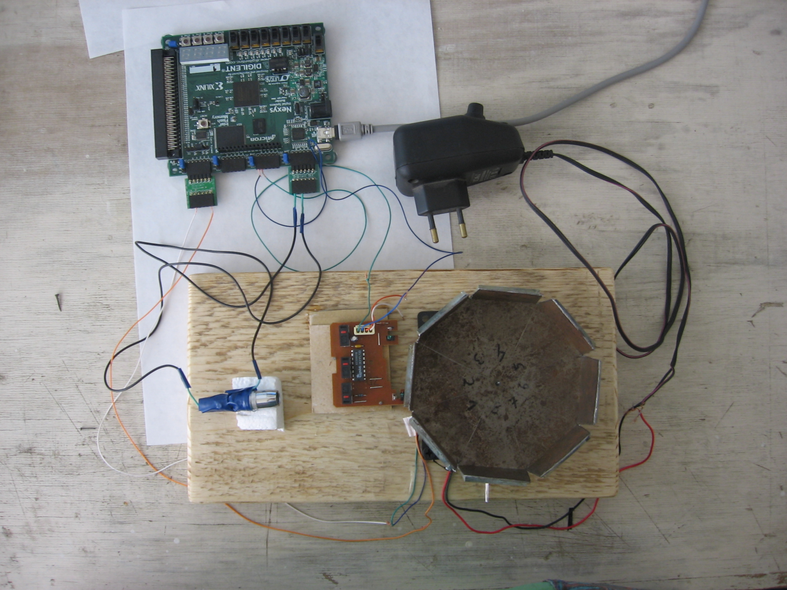

Introduction

This report presents the design of a circuit of a mini Laser Projector. The project requires a Nexys System Board, Digital Input Peripheral Module, Open Collector Peripheral Module, one computer mouse, 80x80x25 12v cooling fan and a small pocket laser.
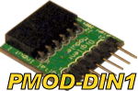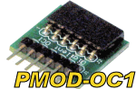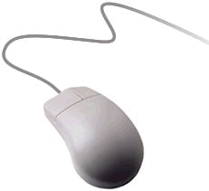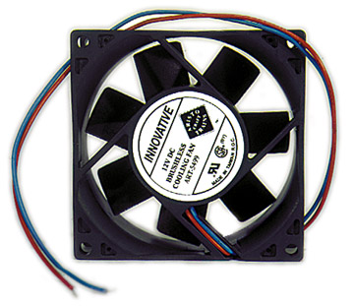

The laser will be connected to the Nexys by the Open Collector Peripheral Module, which will light up and shut down the laser. One optical sensor from the mouse will be connected to the Digital Input Peripheral Module. Using the sensor we can syncroniz the laser beam with the rotating fan which has 8 mirrors mounted on it.

The design is complete, meets all requirements, and it has been verified through component simulations and physical implementation.

The circuit is defined in VHDL, and it targets a Xilinx Spartan-3 FPGA. Since all source files are VHDL, they can be used on other type of Xilinx FPGAs. The circuit was designed on a Windows XP PC using the Xilinx WebPack 7.1i CAD tool.

Background

The most important component used for laser projectors is the laser unit, He-Ne laser had been used in early days, multi-colored mixed gas laser is currently used for high end laser projector and solid state laser is one of the brand-new laser device that has been recently used. After the laser the next important part is the blanking mechanism and X-Y scanner. The most common projectors look like this:
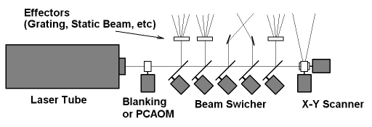

At this project the X-Y scanner was changed by 8 rotating mirror. The X coordinate is drawn using the rotating mirror:

Each mirror has a different angle to control the Y coordinate:
So with 8 mirrors you can draw 8 different lines.

To draw more lines we can use more mirrors and/or we can use more lasers.

Design

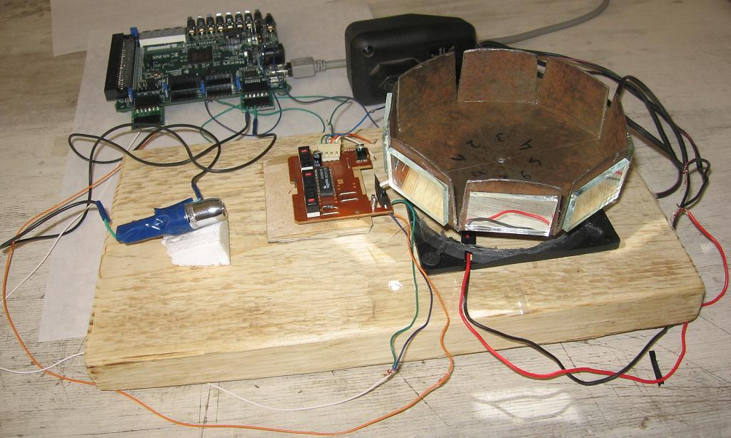

Nexys
DIN1
OC1
VU
+
--
J4
LASER
J1
GND
SENSOR
mouse
LED
VU
GND
+
--
FAN

As you can see from the following image I cut down one sensor from the mouse and connected it to the DIN1 module. The mouse is connected to the VU (5v) and GND pins from the Nexys.
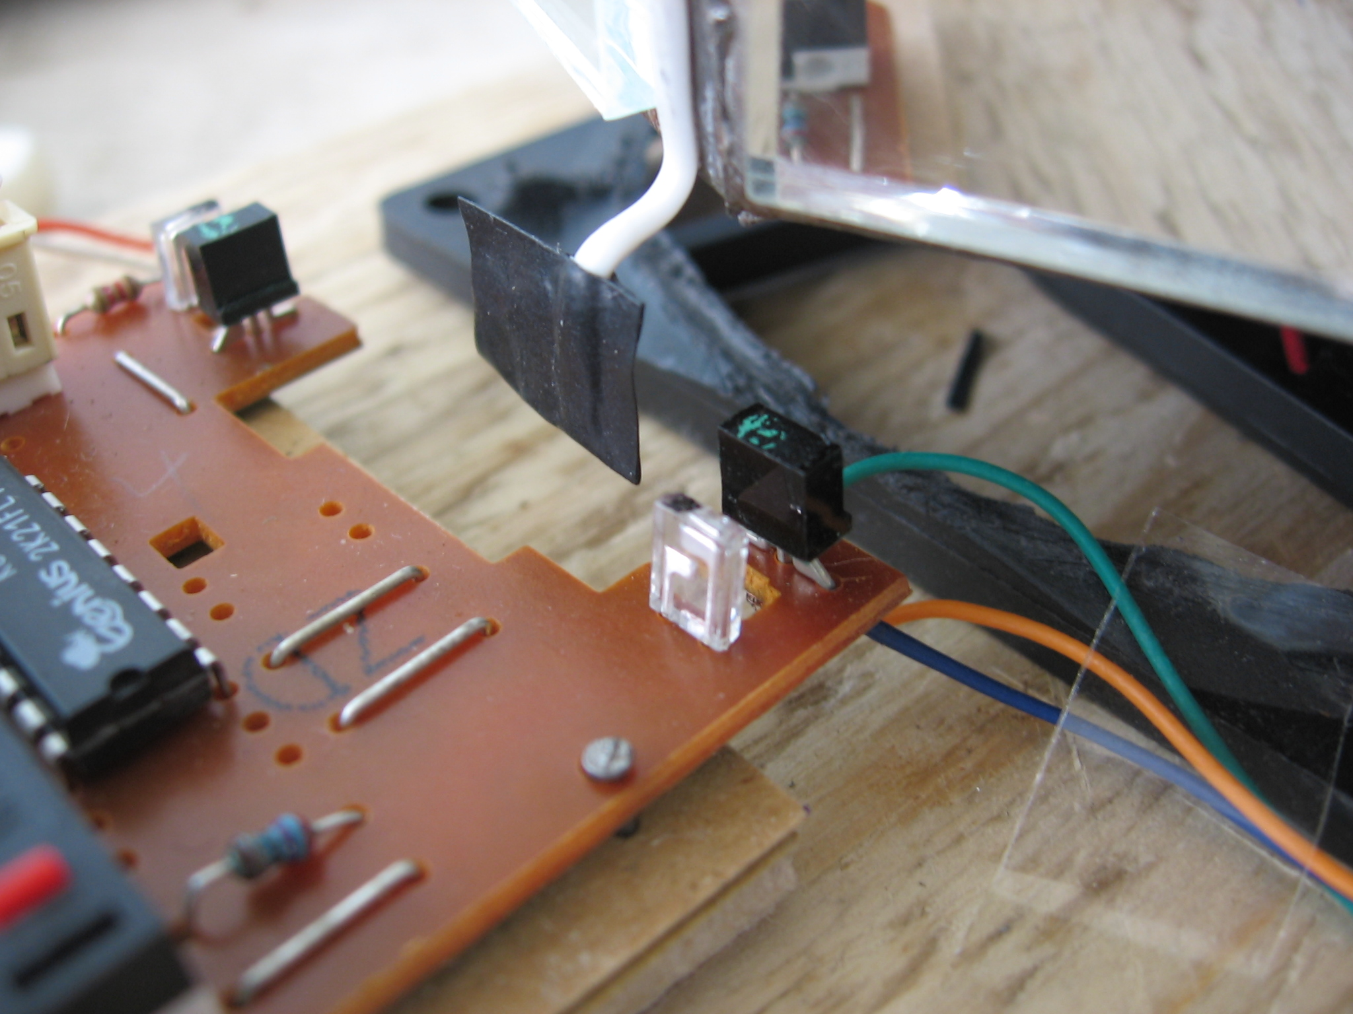

dinkc
swt
mclk
led
an
ssg
oc1
Signal | Mode | Description
mclk | Input | Main clock input
din | Input | Digital input(JD ports)
swt | Input | Switch inputs
led | Output | Led
an | Output | anod
ssg | Output | Seven segment
oc1 | Output | Open collector output(JA ports)

Using the “din” input we can read the photo sensor from the mouse. When we read ‘0’ then we know that the fan is at a certain position. Counting the clocks beetwen two ‘0’ we can calculate the fan’s frequency and we can syncroniz the mirrors. This number is divided by 8 because we have 8 mirrors and memorized in “time0”.

time1 – numbers of clock while the fan makes one rotation

time0 = time1 / 8

time2 – will count from time0 to 0
- when time2 = time0 / 2 we know that the laser is pointing to the middle of one mirror
“time2” will get the “time0” value and will count down this clocks. At the half of that number is the middle of the mirror where we want to draw the image.
“if time2="00000000000000000000000" then
time2<=time0;
line<=line + 1;
elsif line="000" and time2(21 downto 12)<(time0(22 downto 13)+ 19)
and time2(21 downto 12)>(time0(22 downto 13)- 14) then
col<=(time0(17 downto 13)+ 18)-time2(16 downto 12);
vidon<='1';
time2<=time2 - 1;
……”
Every time when “time2” gets to 0, the “line” will be incremented. The “line” and the “col” variables are used as Y-X coordinates in the image and are connected to BlockRAMs as address input.
After the mirrors were adjusted and you try to draw a vertical line the chances are high that you will see something like in the first image. This is because the mirrors are not perfectly perpendicular to the fan’s middlepoint.
To correct this bug you can try to work on the mirrors position or to change the starting position of each line. When time2(21 downto 12)=time0(22 downto 13) – than the laser is pointing to the mirrors middle, so the laser is activ when -- time2(21 downto 12)<(time0(22 downto 13)+ 17) and time2(21 downto 12)>(time0(22 downto 13)- 16) --. To change the starting position of the line we change the number with the red color.

To obtain the best image with my projector the image must be projected to 20-50cm distance. To draw the pixels I am using ~12000Hz, this depends on how far you must create a pixel.

I made two different project which are working on the same principle, but they are using and reading other type of BlockRAMs. One is the laser_video_projector, which is using 4 BlockRAMs which contains the images and the other project is laser_text_projector, which contains 2 BlockRAMs: one contains the characters and the other contains the characters form.

Laser_video_projector

The video.vhd component contains 4 BlockRAMs which memorizes 256 different images. To make easier to create images I made a small image-video editor in Java:

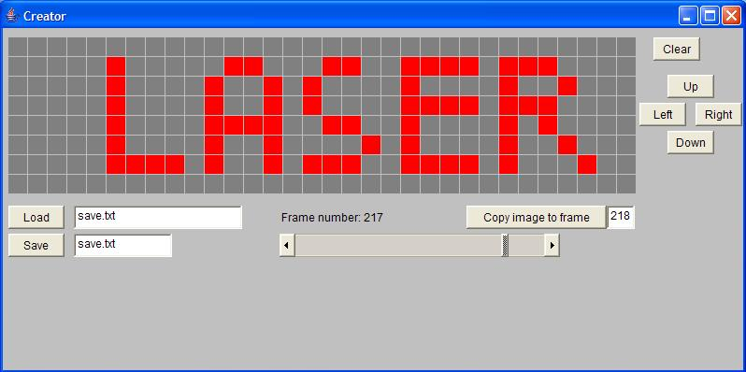

You can draw 256 different images and save it as a text file. Saving the images will create the initialization vhdl code for the BlockRAMs and you only need to copy the text in the video.vhd file. Also the saved file can be loaded to the program for other changes.
One image contains 8x32=256 pixels. For drawing you can use two mouse buttons:
- clicking on the pixel will change the pixel’s color
- holding down the left mouse button will draw red color
- holding down the right mouse button will draw grey color
The program can be used to preview the video.

The “frame” variable is also an address input for the BlockRAMs and it is incremented by every second rotation of the fan, this will make to change the image.

Laser_text_projector

This component uses two BlockRAMs: one contains the characters and the other contains the characters form.
Here I am using a bigger screen to draw the image: 8x64 = 512 pixel.
One BlockRAM is a 2k x 8 + 1 Parity bit Single-Port RAM, which can memorize 2048 character. The data output of this RAM is taken as a part of the address input of the other RAM, which contains the character’s form.
In one BlockRAM we can memorize 256 different character’s form. To draw a character I need 8x8 pixels (64 bits). Here you can see a part from the RAM’s initialization:
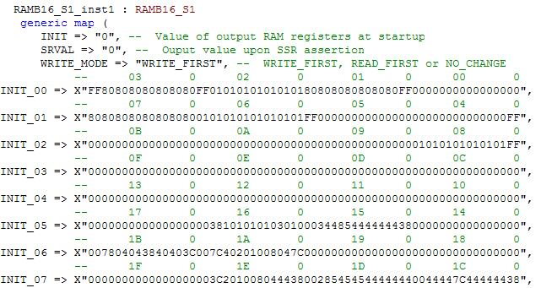
To make easier to understand how its working I wrote the character’s codification above the memory part where the character’s form is kept.
To memorize a character’s form do the following steps:
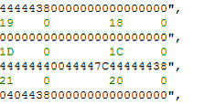
3) write the cod in the BlockRAM, ex: the ‘A’ character’s form I keep at the “1C” address
"00111000" == 38
"01000100" == 44
"01000100" == 44
"01000100" == 44
"01111100" == 7C
"01000100" == 44
"01000100" == 44
"00000000" == 00
1) draw the character’s form like this and convert the bit cod to hex

0044447C44444438
2) write down the hex code beginning with the bottom number
To make the characters to move from the right to the left the following lines are responsible:
“cc<=col(2 downto 0) - frame;
car<=caracter + 7 - col(5 downto 3) when col(2 downto 0)>=frame else
caracter + 8 - col(5 downto 3);
addres<=car&line&cc;”
“frame” is incremented by every second rotation of the fan, this will make the text to move.

Discussion

The hardest part of the project is to adjust the mirrors. It is recommended to use a hard, but light material on which the mirrors will be glued. An other problem that I encountered is that the mirrors change their position with the fan’s rotating speed.

The clock which will be used to draw a pixel depends on how far the image will be from the mirrors. The biggest problem to adjust the mirrors, for far distances it is almost imposible to adjust the mirrors with hand.

Using lenses we can enlarge the pixels.

References

1. Home Built Laser Projector:
http://elm-chan.org/works/vlp/report_e.html

2. How Laser Shows Work - Laser Projector:
http://www.laserfx.com/Works/Works3.html

3. Xilinx ascii code mapping:
http://www.xilinx.com/products/boards/multimedia/docs/examples/ascii_code_mapping.pdf

